Connor-Francis McGrath

DATT 2501

216869133

February 6, 2022

**Project 1**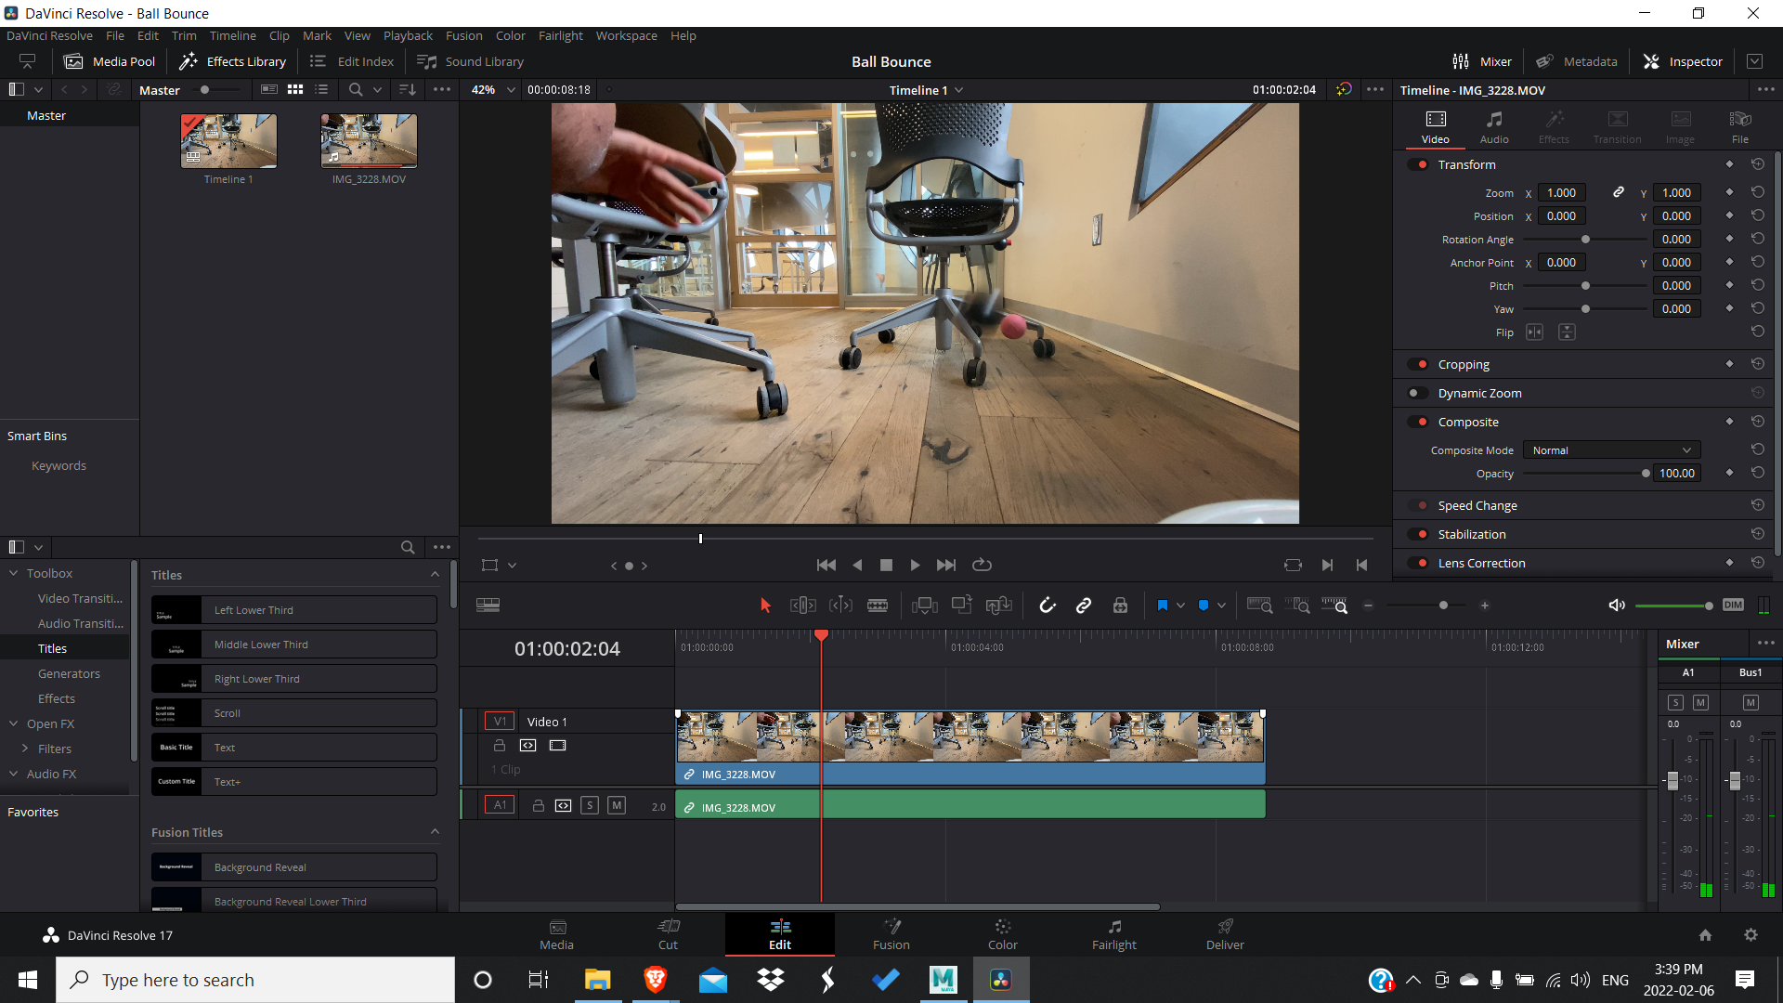

For my project I decided to make an animation of me throwing a rubber bouncy ball and a stress ball. I used a video I took as a reference for timing.

I used two copies of the rig that was set up in tutorial 2 to make the two balls.

I started with translation on the Y-Axis for the rubber ball.

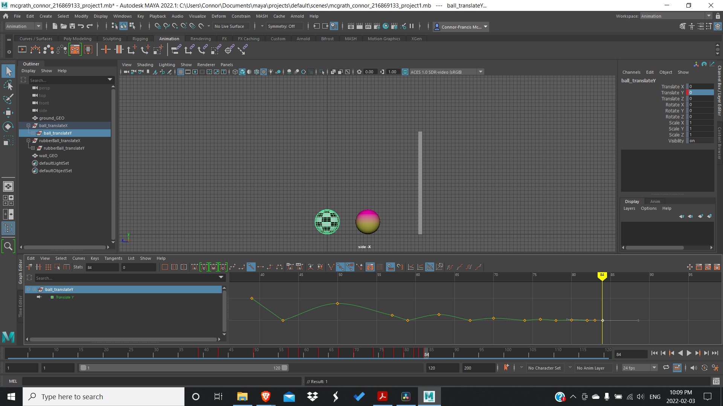

First I keyed the peaks of the bounces and when it made contact with the ground.

It stops bouncing after 3 seconds, or frame 72, so I keyframed frame 72 to 0.

I decided that 30 would be the starting height. So frame 1 was keyframed to 30.

Frame 5 was when it hit the ground first, so it was keyframed to 0.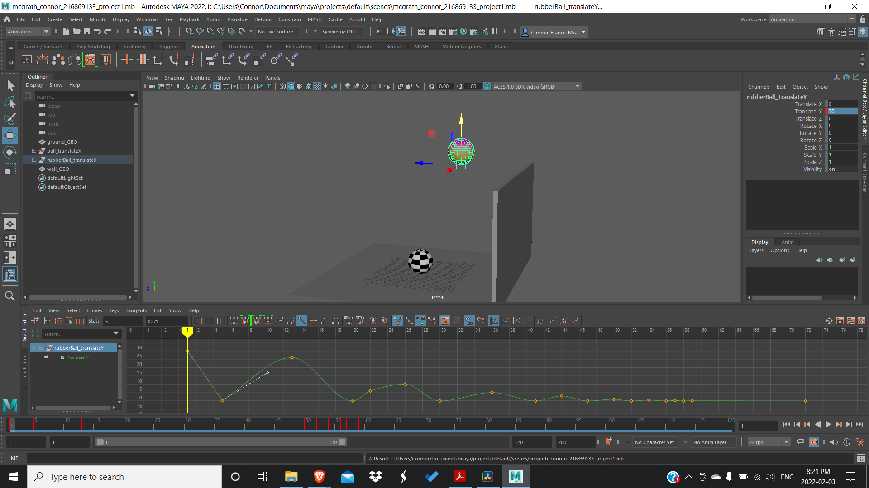

Because it’s a bouncy ball it didn’t lose a lot of momentum, so frame 13, the peak of the first bounce, was set to 26.

I continued with this process for each successive bounce, losing momentum with each one

I then went into the graph editor and made all the keyframes when the ball lands linear so that the ball doesn’t slow down before hitting the ground.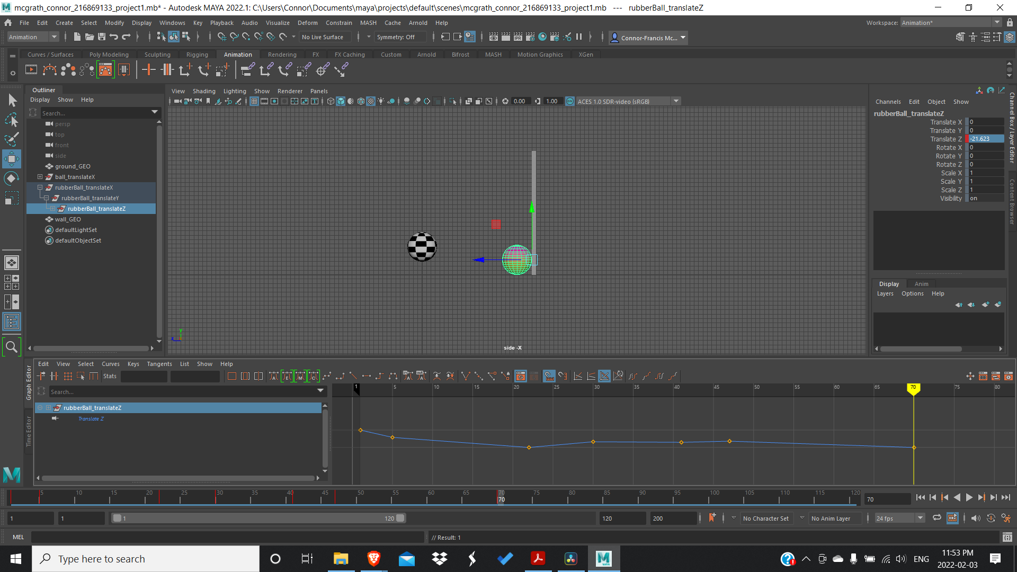

I then started the vertical movement of the stress ball. Because the stress ball isn’t as elastic as the bouncy ball, I made it lose more of its momentum after every bounce. For example, both balls started at 30 in the Y-Axis, after the first bounce, the bouncy ball was set to 26, whereas the stress ball was set to 23.

Now that the vertical movement was finished, I then worked on the horizontal, which in my case was the Z-Axis.

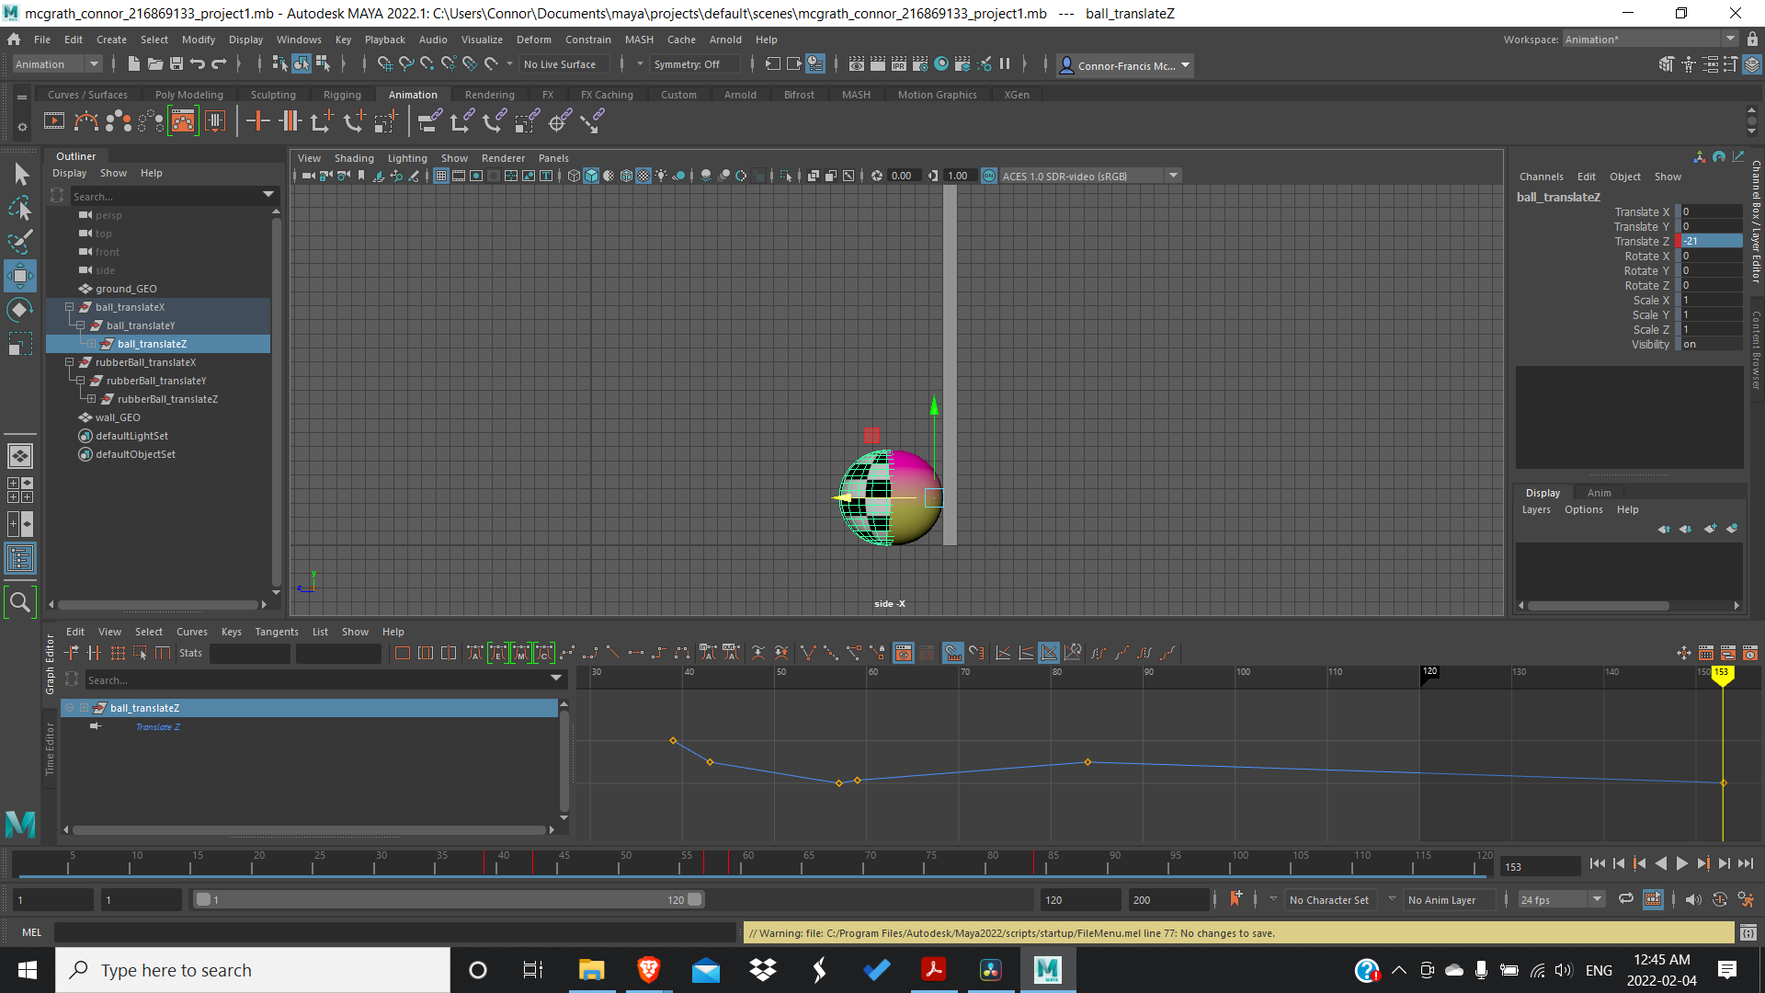

First the bouncy ball.

Looking at the video I saw that at frame 22 the ball hit the wall so I aligned the pivot of the ball with the wall and set a keyframe.

Afterwards I realized while I freezed the transformations so that 0 was the ground on the Y-Axis, this made the translations relative and a lot easier to keyframe. I neglected to do this on the Z-Axis and it made the translations much harder to complete.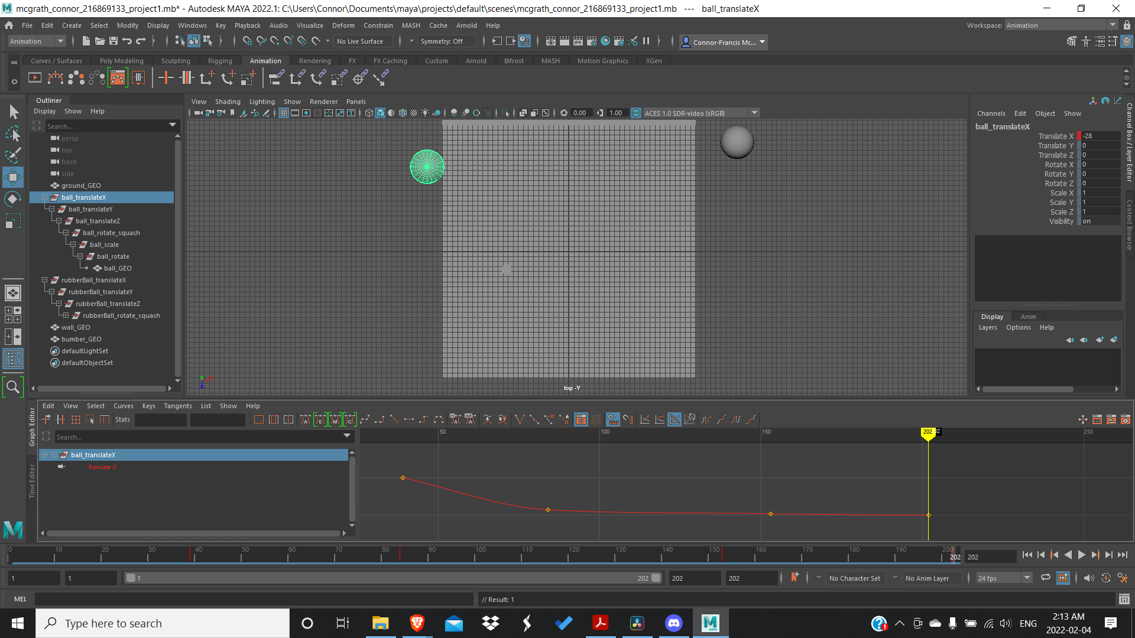

In the space I filmed the distance from the wall to my hand was twice the length of the distance from my hand to the ground. So I made the beginning position of the ball on the Z-Axis 60 units in the negative direction from the wall.

Then I added the keyframes after it bounced off of the wall.

Once I added the keyframes I had to make them linear, except for when they were rolling to their final position, those stayed gradual because they decelerated to a stop.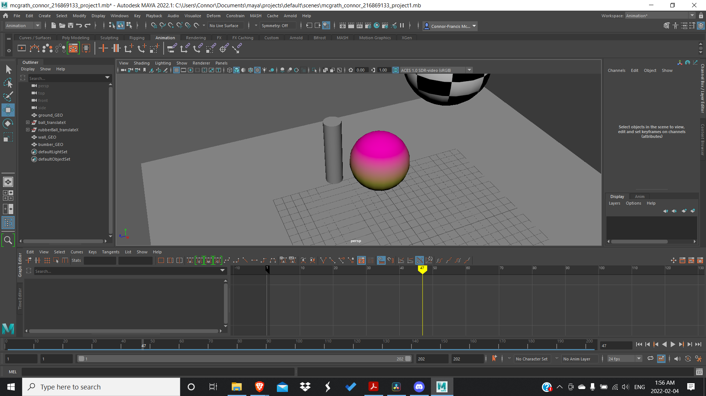

Then I repeated the process for the stress ball.

After the Z-Axis translation was done I worked on the translation on the X-Axis

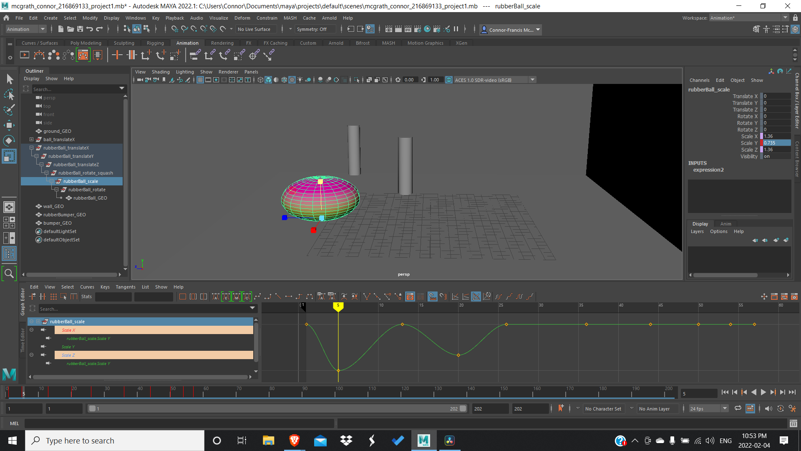

First the rubber ball.

I noticed that even though the ball moved on the X axis after bouncing off the wall my animation had the ball hit the wall orthogonally, which doesn’t make any sense, so I had to give the initial throw some slight movement on the X-Axis.

I then added a cylindrical bumper for the rubber ball to bounce off of. In the video, it was the leg of the chair.

Then I worked on the X-Axis movement for the stress ball, which entailed adding another bumper to bounce off of.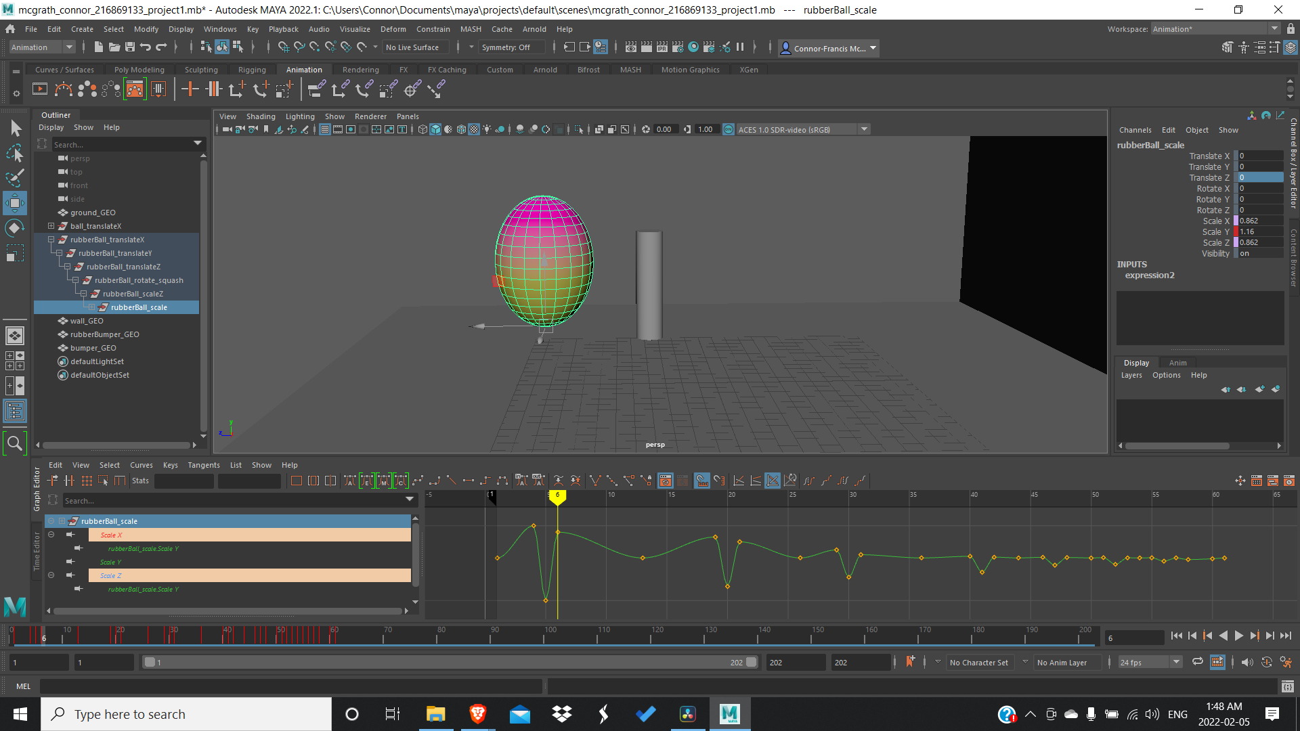

After movement in the X-Axis was done I began to work on squash and stretch.

First I keyframed all the areas where the ball has no squash or stretch, that being at the peaks of its bounces.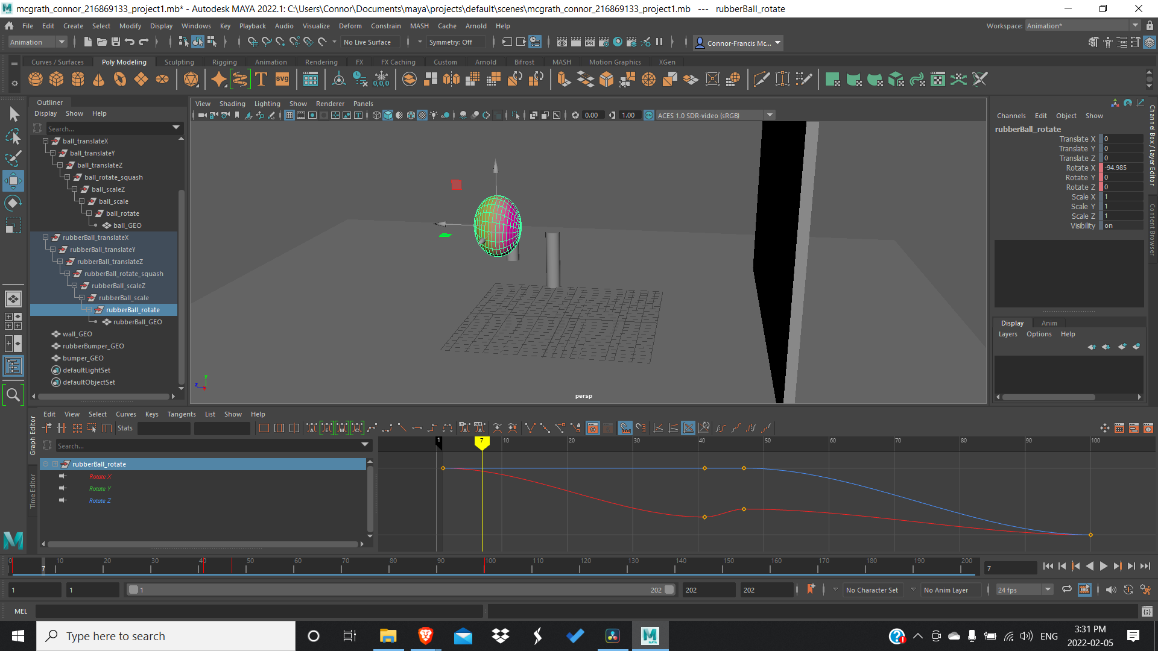

Then I keyframed the next extreme, when it hits the ground and changed the scale on the Y-Axis. Because of an expression I applied to the ball, it changed the X and Y scale so that the ball retained a consistent volume.

I decided to give the rubber ball a large squash and stretch to emphasize its elasticity.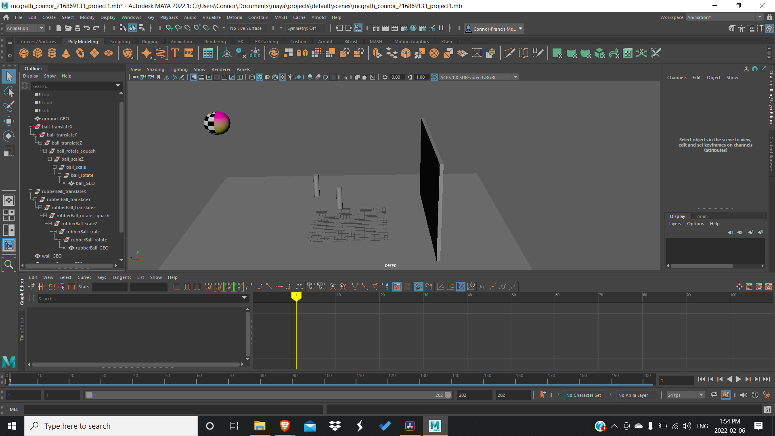

I decided it should have some squash when it hits the wall and bumper as well, so I added another group for handling the non-vertical squash, using the same expression for the vertical squash to maintain a consistent volume.

The stress ball is a lot less bouncy than the bouncy ball so, I had it squash and stress less, and lose more of it with every bounce.

Now that I was finished with the squashes, I decided to do the stretches next for both balls.

I added the stretches one frame before and after the squash keyframes so that the ball wouldn’t squash before it hit the ground.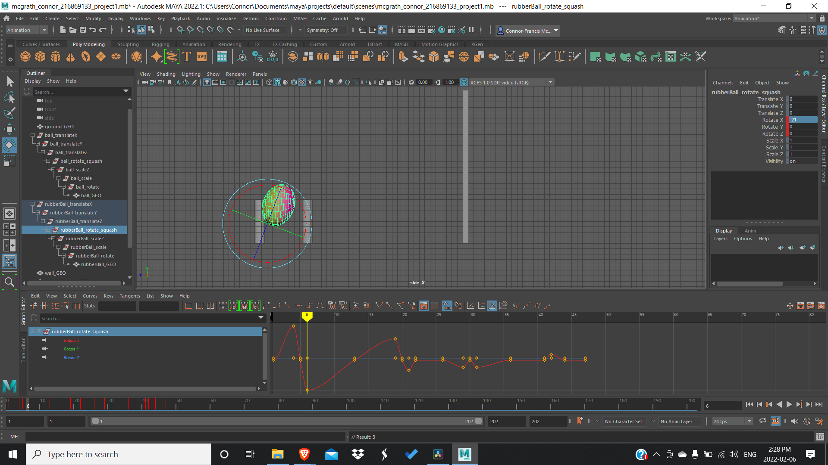

I then worked on the rotations.

In the video the rubber ball rotates in one direction until it bounces on the ground after hitting the wall, so I put a keyframe at the start and another where it bounces and rotates the ball an appropriate number of times.

I had a lot of trouble with the rotations and figuring out which axes to move. I was finally able to fix them by placing the keyframes on the right frames and then editing the vertices on the graph editor.

Because my rotate group was below the scale group, the ball was still straight after rotating it, so I added another group above the scale to rotate the squash and stretch.

First I keyframed the first extreme, when it would be completely straight, at the top of the arcs and when it hits the ground.

Right before it hits the ground I rotate it towards the ground, and when it bounces up I rotate it away from the ground. Getting less intense every time it happens.